

# Experiment No. 2

**Aim –** To Build Your Application using AWS Code Build and Deploy on S3 / SEBS usingAWS Code Pipeline, deploy Sample Application on EC2 instance using AWS CodeDeploy.

# Theory –

## AWS Code Pipeline

* Continuous deployment allows you to deploy revisions to a production environment automatically without explicit approval from a developer, making the entire software releaseprocess automated.
* You will create the pipeline using AWS CodePipeline, a service that builds, tests, and deploys your code every time there is a code change.
* You will use your GitHub account, an Amazon Simple Storage Service (S3) bucket, or an AWS CodeCommit repository as the source location for the sample app’s code.
* You will also use AWS Elastic Beanstalk as the deployment target for the sample app.
* Your completed pipeline will be able to detect changes made to the source repository containing the sample app and then automatically update your live sample app.

## AWS Code Build

* AWS CodeBuild is a fully managed build service in the cloud. CodeBuild compiles your source code, runs unit tests, and produces artifacts that are ready to deploy.
* CodeBuild eliminatesthe need to provision, manage, and scale your own build servers. It provides prepackaged build environments for popular programming languages and build tools such as Apache Maven, Gradle, and more.
* You can also customize build environments in CodeBuild to use your own build tools. CodeBuild scales automatically to meet peak build requests.
* You can add CodeBuild as a build or test action to the build or test stage of a pipeline in AWS CodePipeline. AWS CodePipeline is a continuous delivery service that you can use to model, visualize, and automate the steps required to release your code. This includes building your code.

## AWS S3

* Amazon S3 (Simple Storage Service) is a highly scalable, durable, and secure object storageservice provided by AWS. It is designed to store and retrieve any amount of data from anywhere on the web.
* Here’s an overview of some key concepts and features of AWS S3

# Steps:

## Create your project / source code. / Get your any project.

In this step you can need to choose any existing project you wanted to deploy, orcreate new project / source code. You can push to any git server.

## Create a buildspec.yml file

In this step, you create a build specification (build spec) file. Without a build spec, CodeBuild cannot successfully convert your build input into build output or locate the build output artifact in the build environment to upload toyour output bucket. Create this file, name it buildspec.yml, and then save it in the root (top level) directory.



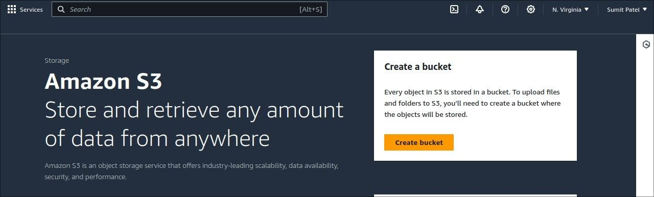

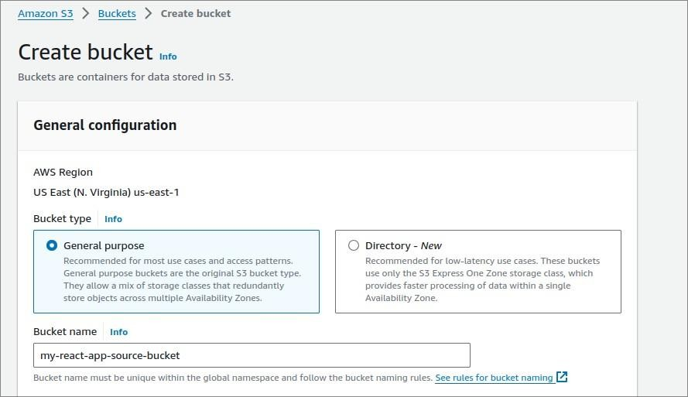

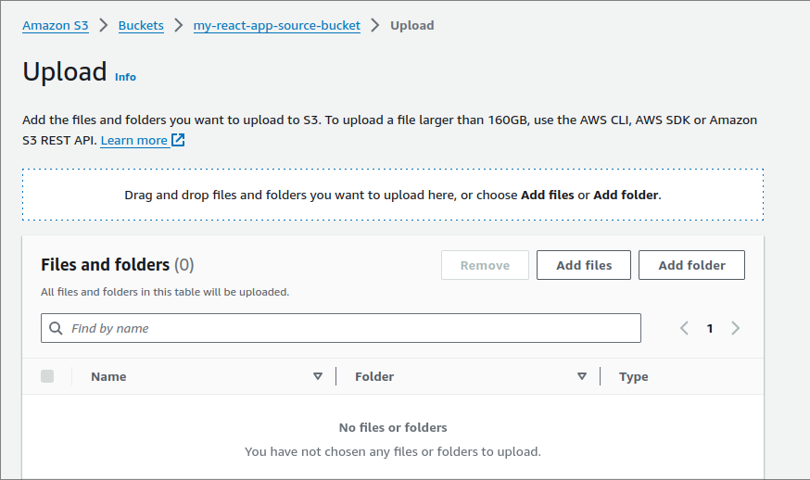

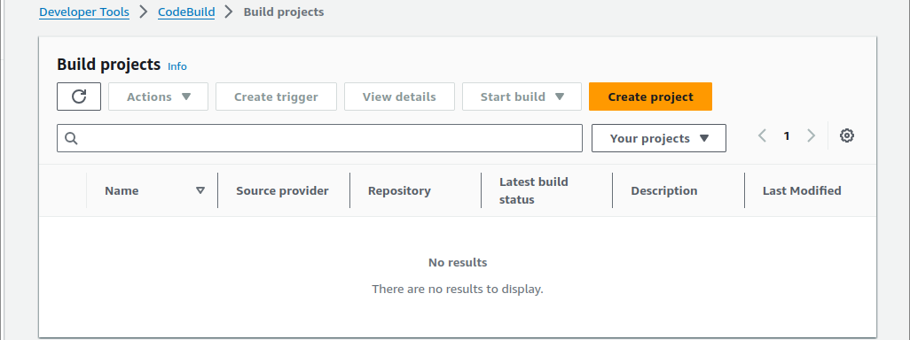

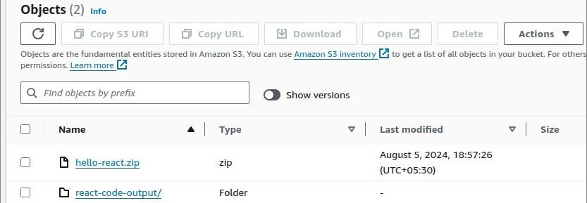

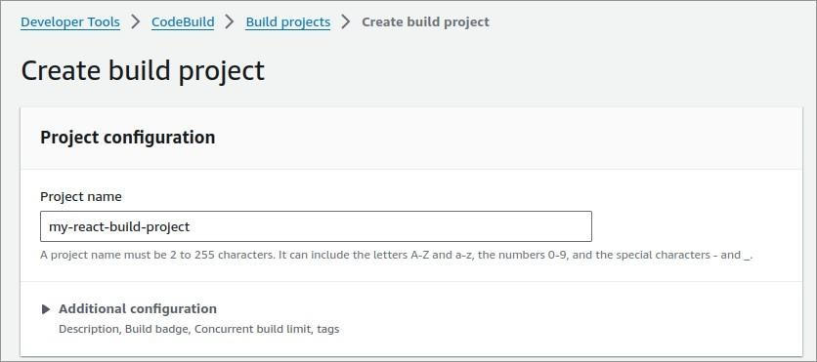

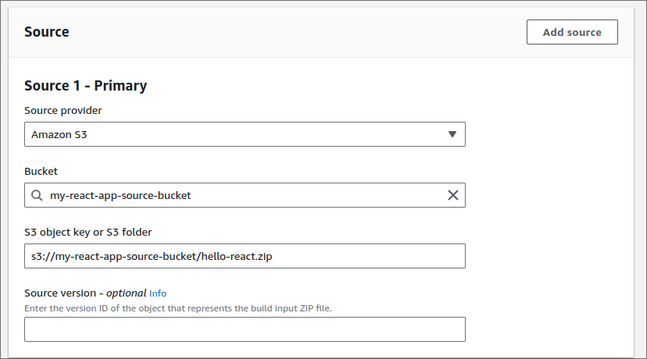

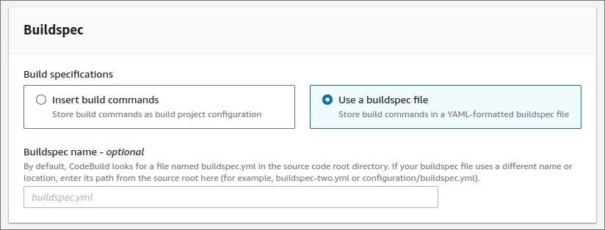

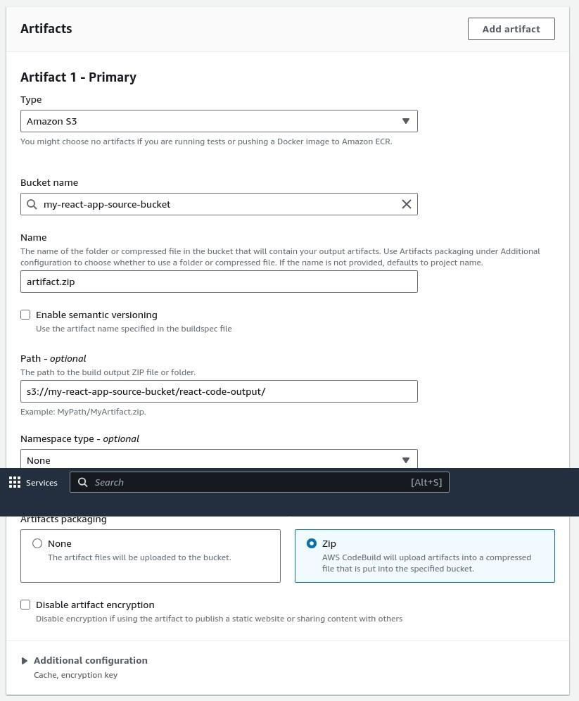

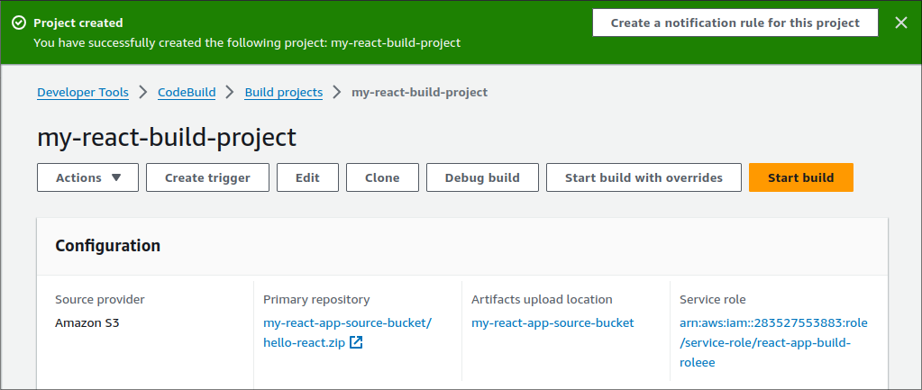

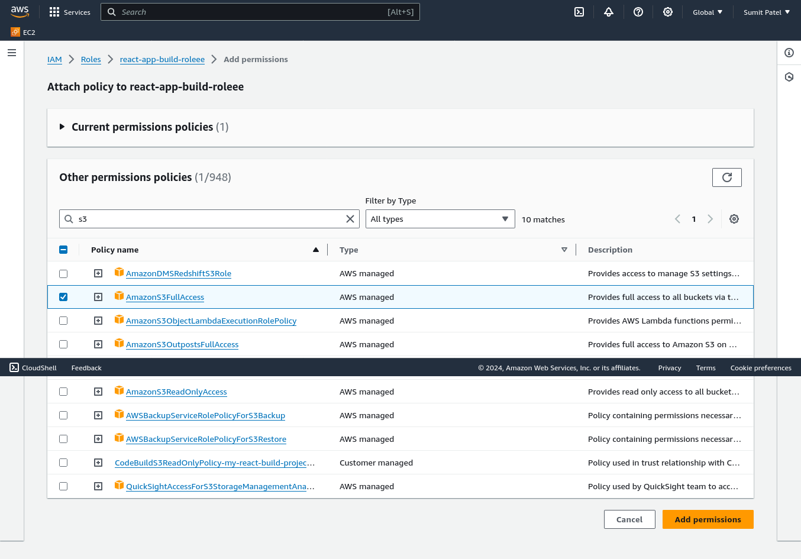

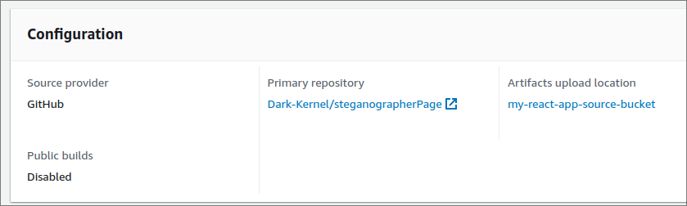

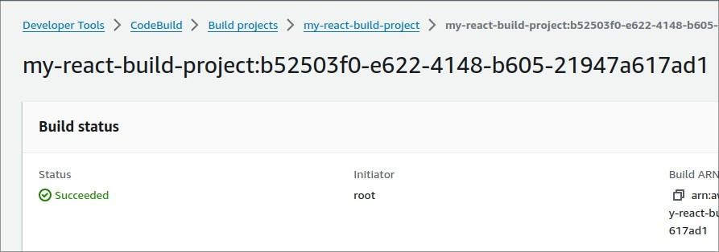

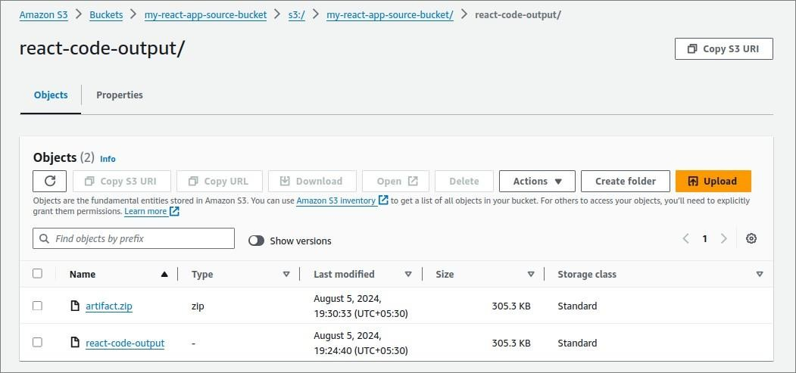

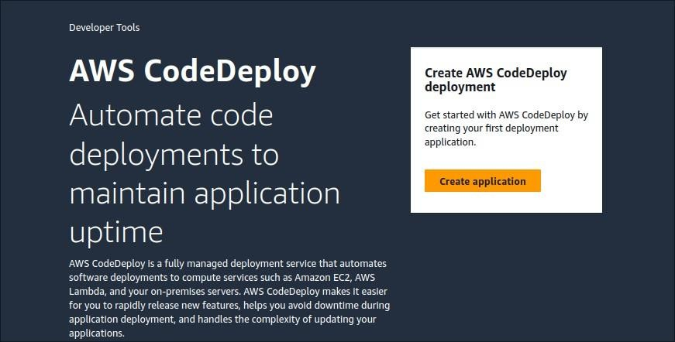

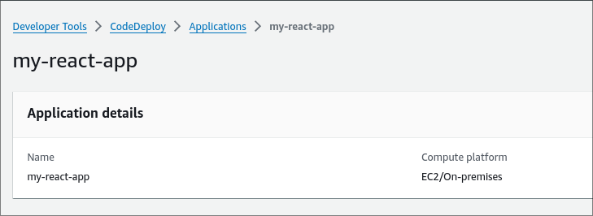

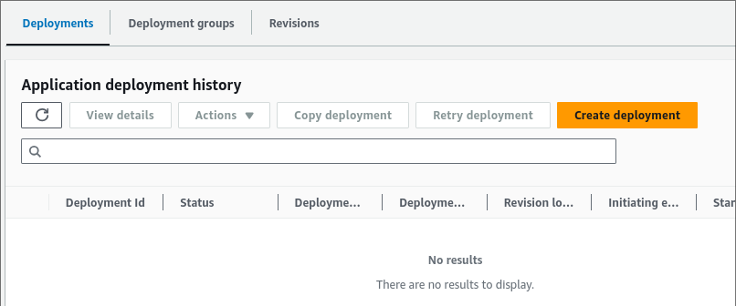

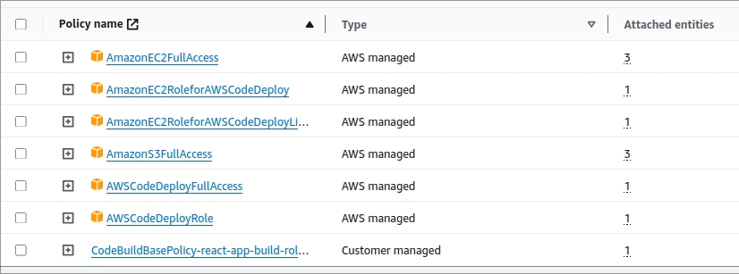

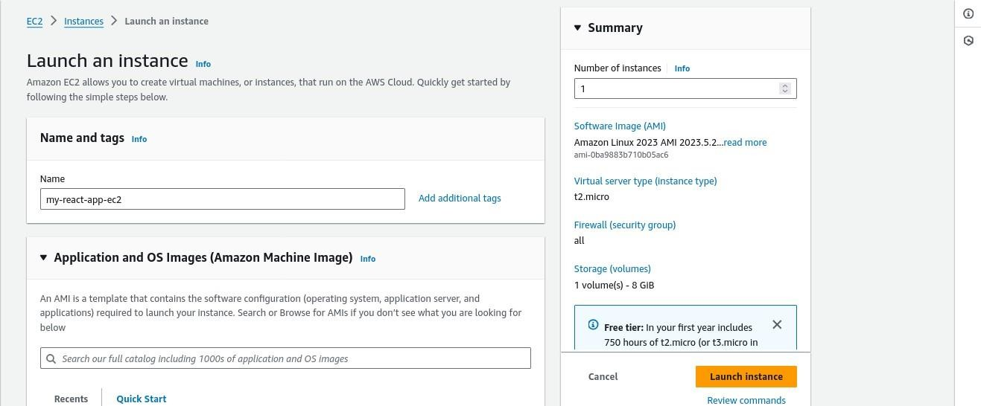

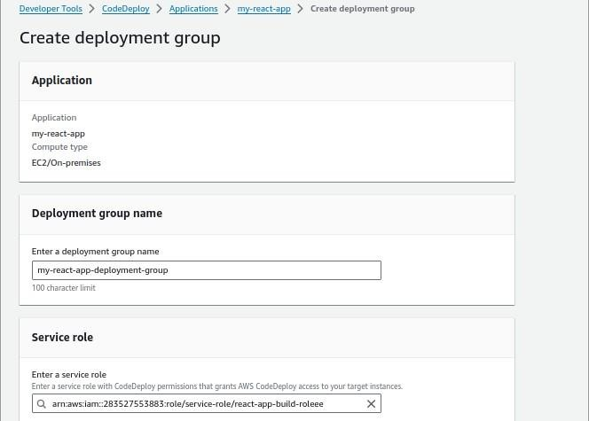

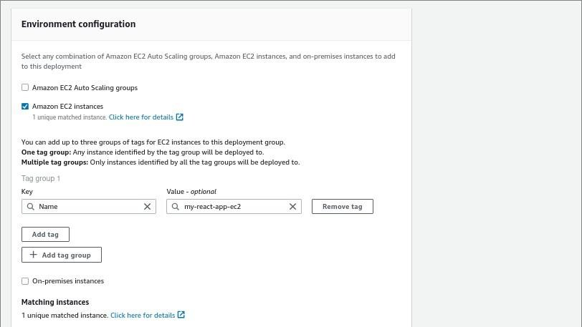

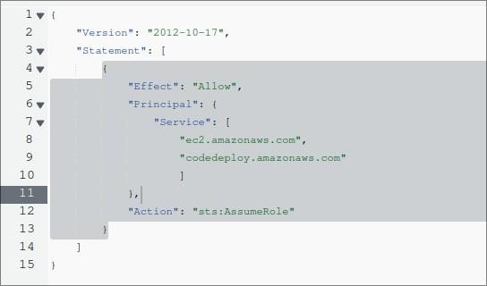

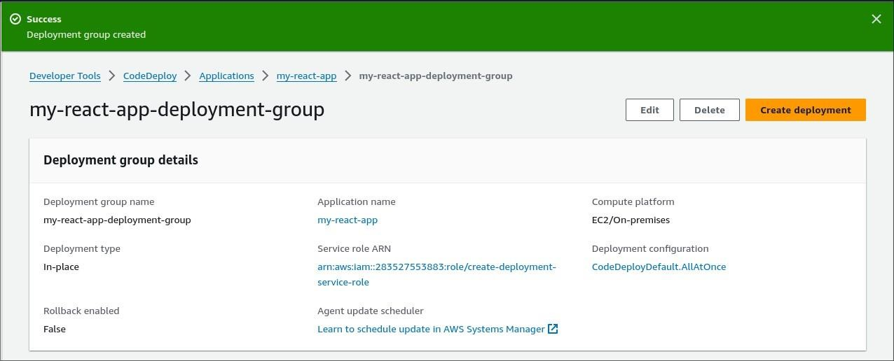

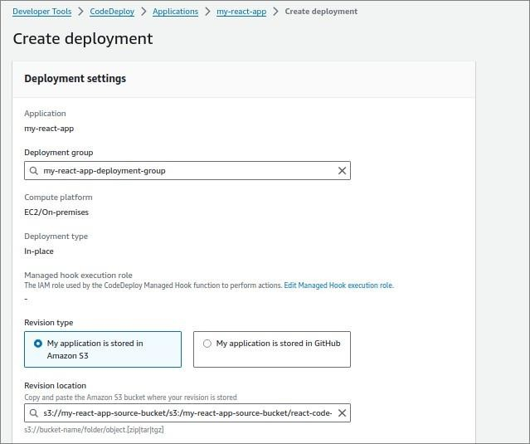

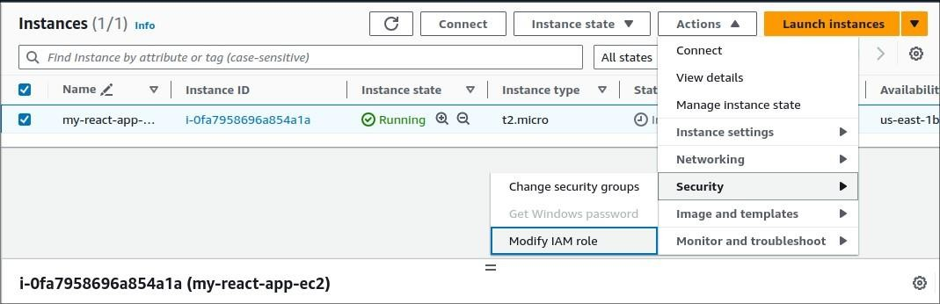

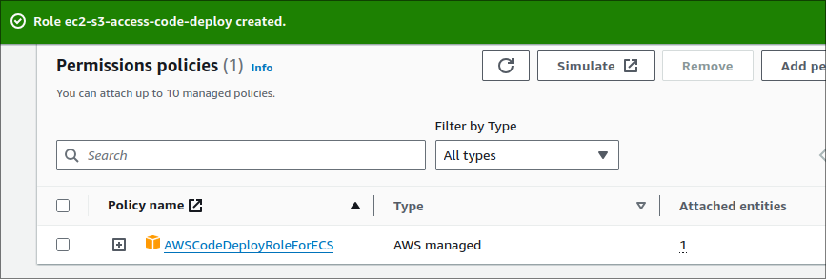

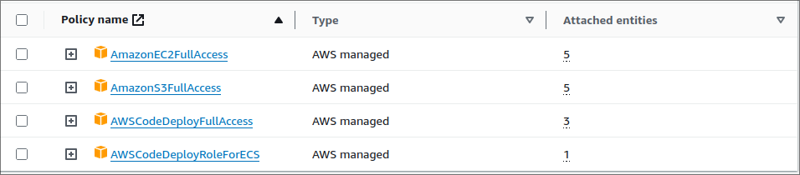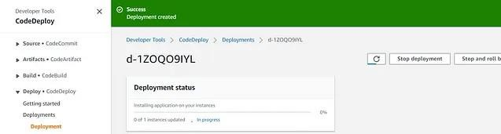

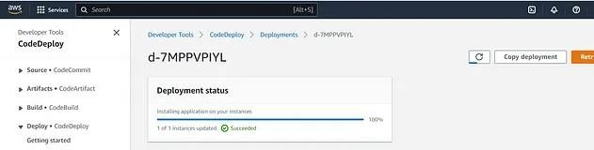

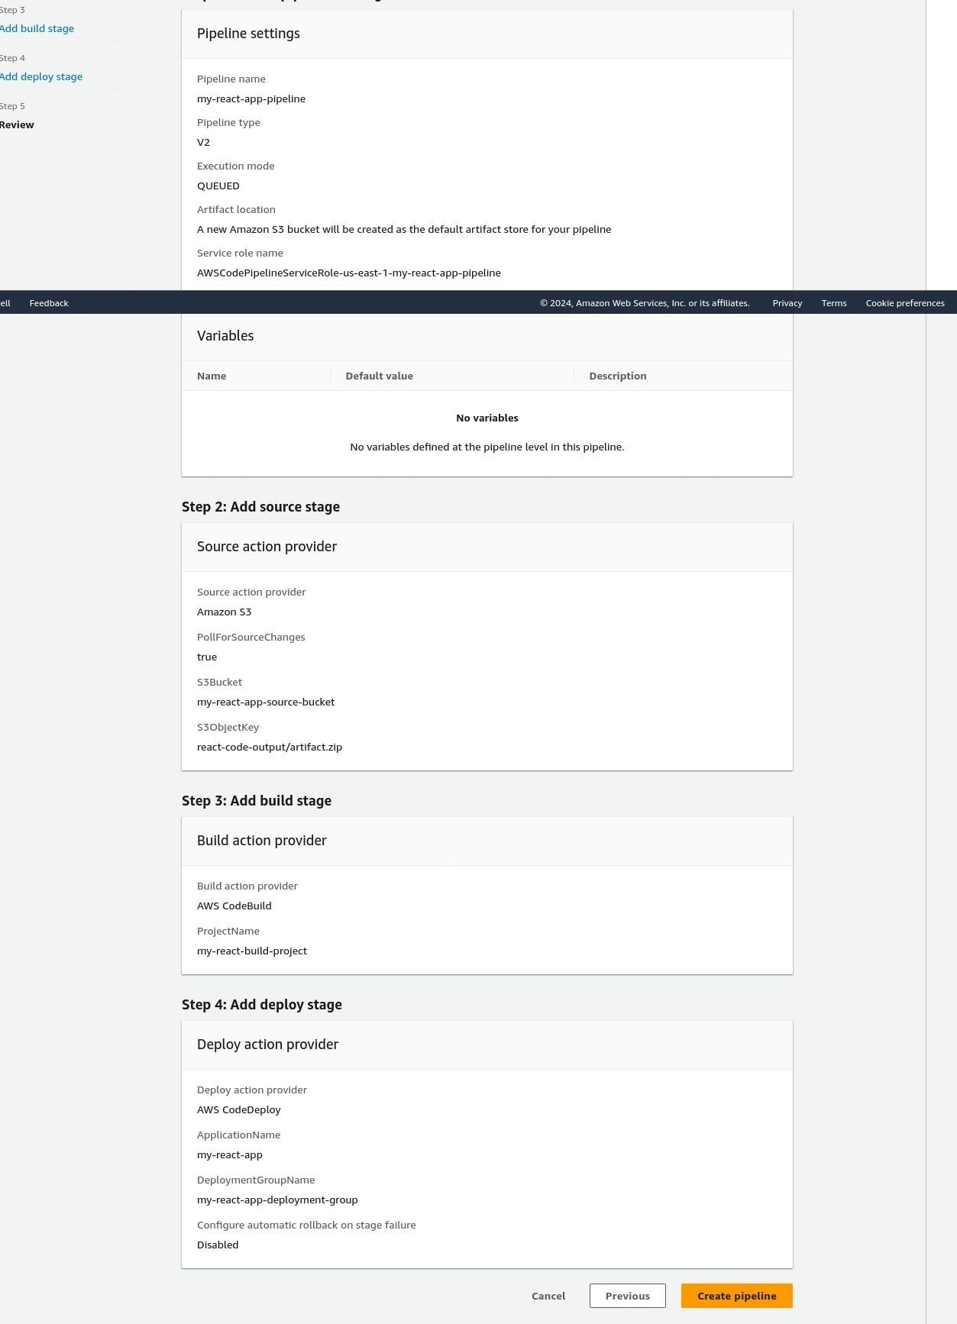

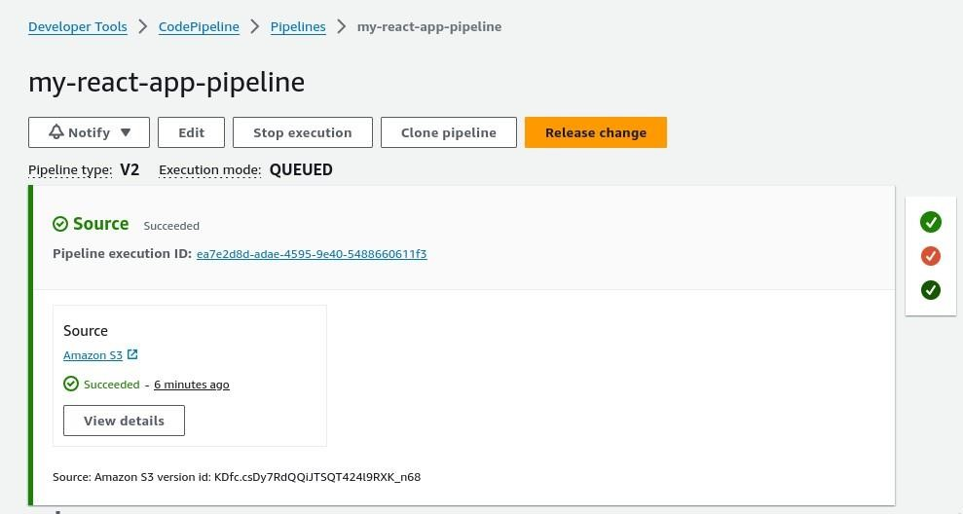

# Conclusion –

Thus, we have successfully Build our Application using AWS Code Build and Deploy on S3 / SEBS using AWS Code Pipeline, deployed SampleApplication on EC2 instance using AWS Code Deploy.